Github basics. Kinda.

# 000

Start of by installing the desktop client. We will probably work shop some other time over the full power of version control.

Go to desktop.github.com

# 001

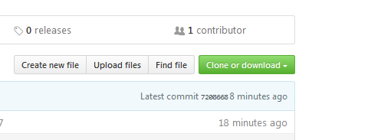

Click the clone or download button followed by: Open in desktop

# 010

After you choose your destination you will have a folder with the files in it.

Let’s all add a text file with our names and put some text in it.

Place the files in this weeks folder.

The changes will show up and you will then follow the arrows to push up to the master branch.

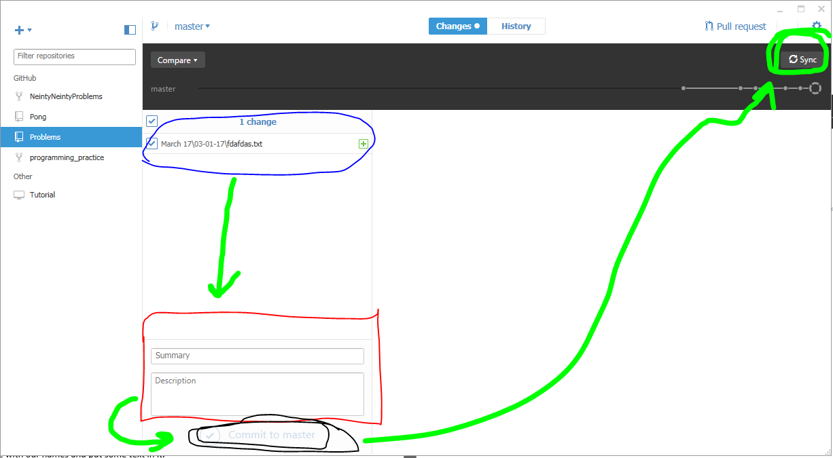

Blue is the files YOU changed. Red is the description you MUST fill in. push the commit to master button. Finally push the sync button to have your commit pushed.